Project Design Phase-II
Technology Stack (Architecture & Stack)

Date | 17 February 2026
Team ID | LTVIP2026TMIDS78778
Project Name | Gemini Historical Artifact Description System
Maximum Marks | 4 Marks

Technical Architecture (3-Tier Cloud Architecture)
The Deliverable shall include the architectural diagram as below and the information as per the table1 & table 2
Architecture Type:
Cloud-based 3-Tier Architecture
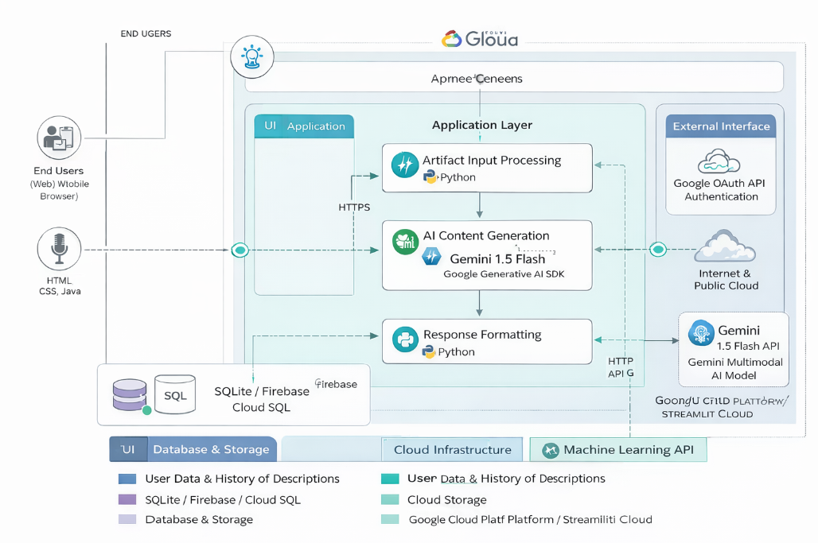

Table-1: Components & Technologies
S.No | Component | Description | Technology
1 | User Interface | Web-based interface where users enter artifact name or upload image | Streamlit, HTML, CSS
2 | Application Logic-1 | Handles user input validation and request processing | Python
3 | Application Logic-2 | Generates prompts and interacts with AI model | Google Generative AI SDK
4 | Application Logic-3 | Processes and formats AI response | Python
5 | Database | Stores user data and history of generated descriptions | SQLite / MySQL
6 | Cloud Database | Cloud-hosted structured storage | Firebase Firestore / Cloud SQL
7 | File Storage | Stores uploaded artifact images | Local File System / Cloud Storage
8 | External API-1 | AI model API for content generation | Gemini 1.5 Flash API
9 | External API-2 | Authentication services | Google OAuth API
10 | Machine Learning Model | Generates artifact descriptions and analyzes images | Gemini Multimodal AI Model
11 | Infrastructure (Server / Cloud) | Application deployment environment | Streamlit Cloud / Google Cloud Platform

Table-2: Application Characteristics
S.No | Characteristics | Description | Technology
1 | Open-Source Frameworks | Frameworks used for rapid web development | Streamlit, Python
2 | Security Implementations | Password encryption, secure API keys, authentication control | HTTPS, OAuth 2.0, SHA-256 Hashing
3 | Scalable Architecture | 3-tier cloud-based design allowing scaling of application and API services | Cloud Deployment, Microservices Architecture
4 | Availability | Application hosted on cloud with minimal downtime | Streamlit Cloud / GCP
5 | Performance | Fast AI response handling, optimized prompt design | Cloud Infrastructure, API Optimization

